Unit Web Design_ Desktop Publishing

Unit is designed for high school, grades 9-12th.

Time frame: 4 weeks. This unit is taught in the end of first semester (end of November – December).

Standards addressed:
D: A student should be able to use technology to express ideas and exchange information.

A student who meets the content standard should:
1) Convey ideas to a variety of audiences using publishing, multimedia, and communication tools;
2) Use communications technology to exchange ideas and information;
3) Use technology to explore new and innovative methods for interaction with others.

Essential questions:
Why do people create websites? How do people create websites? Who can create a website? What are the characteristics of high quality websites?
Objectives
Students will design training web sites, using Weebly.com. Students will create web pages from scratches. Students will create e-portfolios, using any existing software or from scratch. Three students from the class, who showed the best results on the training websites’ project, would participate in a contest of designing a website for Digital Arts classes. Students will write reflective essays at the end of the unit.
Lesson 1

1. Anticipatory set
What is Internet?
What are web servers? What do they host?
What is domain name?
What is the difference between domain name, URL and IP address?
What is HTTP?

2. Web servers and domain names
Tell students about web servers, hosting, URL (Uniform Resource Locator), domain register, IP address, HTTP (standard protocol). Explain difference between IP address and domain name.

Activity:
Ask students to log in to their computers and type http://74.125.91.104/ into the web browser. Compare the results with your partner.

Talk about what kind of services web hosting company provides: fast response time, web statistics, good upload speed, help.
Once your site is online, you expect your web hosting company to provide

3. Types of web sites
Ask students why people create website?
What types of websites do they know?

Tell students about different types of websites: E-commerce, Information sites, Entertainment, Business, Ideas and Opinion sites, Social networking, Portfolio.

4. Activity “Play a matching game”
What types are this websites?

Entertainment  Informational site  Business  Opinion sites  Social networking  Educational  Portfolio  E-commerce | http://www.youtube.com  http://www.facebook.com  http://www.coca-cola.com  http://www.bbc.com  http://phdl.co  http://www.funbrain.com  http://www.feld.com  http://www.ebay.com

Ask students what do they know about two parts of a domain name? Give students lists of domain suffixes and explains the relations between domain name suffixes and web categories. Tell them about different domain name suffix in different countries.

5. Closure: Exit ticket
Log in to your computers and find a website of any country (not USA).

Vocabulary for lesson 1

Web hosting service is a type of Internet hosting service that allows individuals and organizations to make their website accessible via the World Wide Web. Web hosts are companies that provide space on a server owned or leased for use by clients, as well as providing Internet connectivity, typically in a data center.

URL - most web browsers display the URL of a web page above the page in an address bar. A typical URL could have the form http://www.example.com/index.html, which indicates a protocol (http), a hostname or domain name (www.example.com), and a file name (index.html).

Domain name register –an organization or commercial entity that manages the reservation of Internet domain names. A domain name registrar must be accredited by a generic top-level domain (gTLD) registry and/or a country code top-level domain (ccTLD) registry.

An Internet Protocol address (IP address) is a numerical label assigned to each device (e.g., computer, printer) participating in a computer network that uses the Internet Protocol for communication.

Most common used top-level domains:
.aero--For the air-transport industry
.asia--For individuals, companies and organizations in Asia, Australia and the Pacific
.biz--Reserved for businesses
.com--For businesses and commercial enterprises; most companies use this extension.
.coop--Reserved for cooperatives
.edu--For educational institutions and universities
.gov--Reserved for United States government agencies
.info--For informational sites
.int--For organizations established by international treaties comment
.jobs--For employment-related sites
.mil--For the United States military
.mobi--For sites related to mobile devices
.museum--For use by museums
.name--For use by individuals
.net--For networks; usually reserved for organizations such as Internet service providers
.org--For non-commercial organizations
.pro--For use by licensed professionals, such as attorneys and physicians
.tel--For services connecting phone networks and the Internet
.travel--For travel-related services, like airlines, hotels and agents

Lesson 2

- Anticipatory set: pre-test
Give students papers with questions. Give them 5 minutes to write answers.
You need to create a website:
1). What do you start with?
2). What things will you take into consideration?
Collect papers.

- Planning a web site
Tell students that design of web site start with planning. The web site designer needs to know the purpose of the site, whose is its target audience, what information needs to be placed on the site.
According to the provided information, he/she needs to take a decision on how many pages will be on the site and how he will design the site.

- Web design principals

Functional or usable Web design
What is HCI?

Human Computer Interaction (HCI) – The study, planning, design and uses of the interaction between people and computers

There are three 'use' words that capture a more complete view of HCI design. The things we design must be:
useful
users get what they need – functionality
usable
users can do these things easily and effectively
used
users actually do start and continue to use it

Explain to students that functionality or usability is the most important thing for any website. Usability means user-centered design. A usable website is user-friendly, easy to read, it is fast, and it makes users come back. When users arrive at a website, they should understand how the navigation works, where to find any particular section of the site or information they are interested in.

For what page usability is the most important?
Usability is the most important for the Home page – the first page of any site.
Customers visit the home page first and if it is not user-friendly that they will not go to any other pages and will quit the site.

What are the main characteristics of user-friendly website?

Navigation - It shows user his current position and leads to the next step. Consistency is the most important factor of the navigation usability. The color and the fonts should be kept the same as the rest of your website. Another big point is the ability to come back (to home page)

Loading speed is the most influential indicator of how user-friendly the site is. It depends of the quality of the company providing hosting and of the “weight” of the website

Web content
Keep in mind two simple rules, while writing: make the text easy to understand (avoid profound language), and use right words (the ones to persuade users and grab their attention). The content should be skimmable.

Visuals are important. Users feel more comfortable to view pages with much visual content. It gives more information faster and it is more exciting, besides that it is catchy.

Aesthetic Web design
What are the main elements of aesthetic design?

Color – select an effective and color scheme, chose colors that have equal vibrancy and compliment each other (triadic, compound, and analogues color scheme)

Typography – create your own fonts or use stylish fonts (not Times New Roman) for title and headlines. Use easy readable fonts for texts

Layout – organize page elements to create visual hierarchy and interest to direct the eye of webpage visitors

Multimedia – use audio, video, graphics, and animation to make your website interactive

C.R.A.P Principles - Contrast Repetition Alignment Proximity

Accessibility
Your web site should be accessible for people with different abilities (enlargeable pictures for people with vision impairment, videos with sign language translation for deaf people etc.)

- Closure: Crossword “Web design” (15 min.)
Make a word wall. Ask students what new words they learned today and write that on the board.
Give students crossword sheets. Ask them to fill up the crosswords. They can look at the board.

Vocabulary for lesson 2

Multimedia – the combined use of audio, video, animation and other interactive features.
Usability – A measure of the quality of a person’s experience in interacting with a website
Alignment – Placement, position, orientation and grouping of elements.
Proximity – The grouping of related items to create visual unity
Contrast – Occurs when two or more page elements display differently in color, size, shape, texture, orientation, position or movement
Accessibility – The practice of making websites usable for people of all abilities and disabilities
Repetition – The use of repeated visual elements that appear through the pages on a website
Layout – Used to organize page elements to create visual hierarchy and interest, and to direct the eye of website visitors
Typography – Used to improve a website’s readability, establish branding, and enhance the tone or style of the website
Human Computer Interaction (HCI) – The study, planning, design and uses of the interaction between people and computers

Lesson 3

1. Anticipatory set
What are the main elements of webpage?
What webpage is the most important?
How pages are connected?
What are the characteristics of high-quality website?

1. Basic components of a webpage
The picture below shows you the main parts of a typical web page
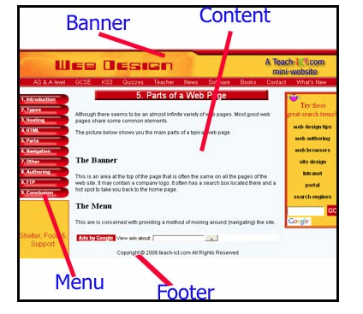

For convenience, designers use templates.

The most important page for website is a home page – customers go to the home page when they type site URL in the browser.

2. Navigation/ Links
Most web sites have more than one page. There are two popular methods of navigating: hyperlinks and menus.

The Hyperlink
When you click your mouse on a navigation hyperlink, it will take you to another page. The page may be on the same web site, but it could just as easily be on another web site. A hyperlink that takes you to another web site is called an external link
A standard hyperlink has a different color to the text around it in order to give you a clue that it is there, it often has an underline as well.
Hyperlinks are also used to download files and documents
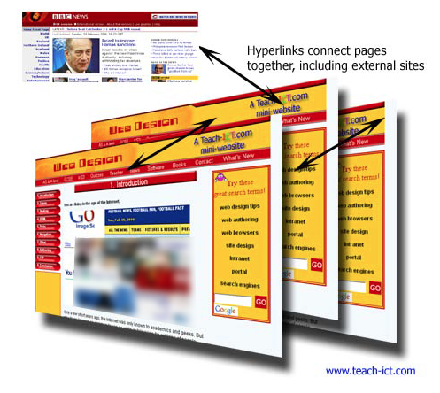

Menu
The navigation menu gives you a choice of which page you want to view next.
A Menu is a set of hyperlinks, grouped together in some way. 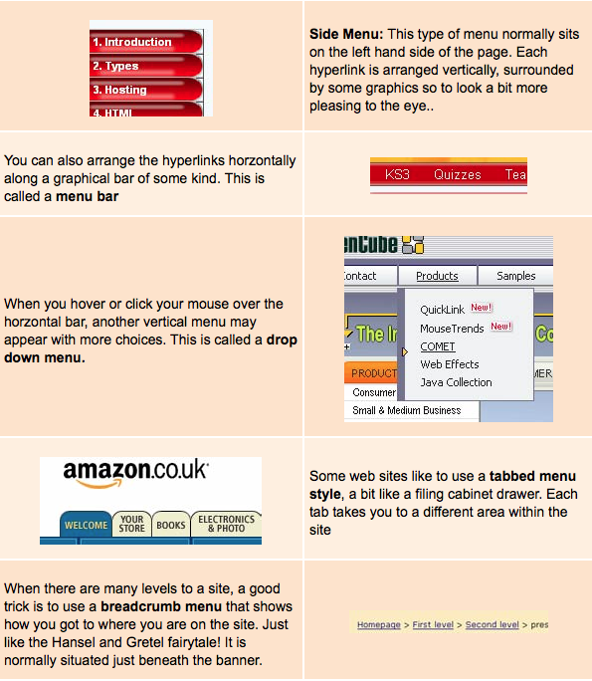

3. Activity Create evaluation tool (rubrics)
- What is a high-quality website? As a group, discuss the question, think about what are the most important things for any website, according to the knowledge that you received on previous lessons, what would you pay attention as a customer, take note.
- What do the experts say? Visit the websites listed below:
- WWW Cyberguide Ratings for Web Site Design (requires Adobe Acrobat Reader)
- Jakob Nielsen: Ten Usability Heuristics
- Designing a Web Site for Yale University Library
- AskTOG: First Principles of Interaction Design
- WebPagesThatSuck.com
- Each of these resources provides someone else's opinions as to what constitutes high-quality websites. Which of these resources do you most agree with? Do you disagree with any of these authors' opinions? Discuss this as a group. Take notes.
- Create an evaluation tool. As a group create a tool to evaluate websites. Each group chooses a presenter, which shares with the class. The teacher or one of the students writes answers on the board. The class should come up with the final evaluation tool (that can become rubrics to assess their own websites).
- Become a web critic. Individually, evaluate 3 websites, provided by the teacher: http://www.trollart.com, http://www.juneauempire.com, http://www.gi.alaska.edu

Lesson 4-5
Design training websites in Weebly.com
Give students packages and guide them through the whole process of creating web sites.
Students need to create websites on the topic, related to the topic of their print advertisements that they made in the beginning of the course. They need to have 5 pages in correct order: Home, About, Services, Gallery, and Contact. Students need to have three attachments: a file from Google Drive, a picture or PDF file (their print ads), and a video from Youtube (their TV commercials).
Students need to fil up the content of website and insert pictures. Pictures should match the content.

Lesson 6-7
Create web pages from scratches, using HTML and CSS.
Give students packages and guide them through the whole process of creating web pages. This unit gives students only basic knowledge of HTML and CSS. For students who want to learn more, a teacher provides a list of html tags and a website www.w3schools.com for self-education and practice.

Lesson 8-15
Give students directions for creating e-portfolios and provide them with rubrics.
Next 2 weeks students work on their e-portfolios. A teacher answer questions, help, and make observations of students working process.

Lesson 16
Students write reflection essay and evaluate their websites: individually, then compare and discuss results in groups of 3-4 people, and then share with the class.

