Create and Design a Web Site in Weebly.com

- Log in/ Create an account
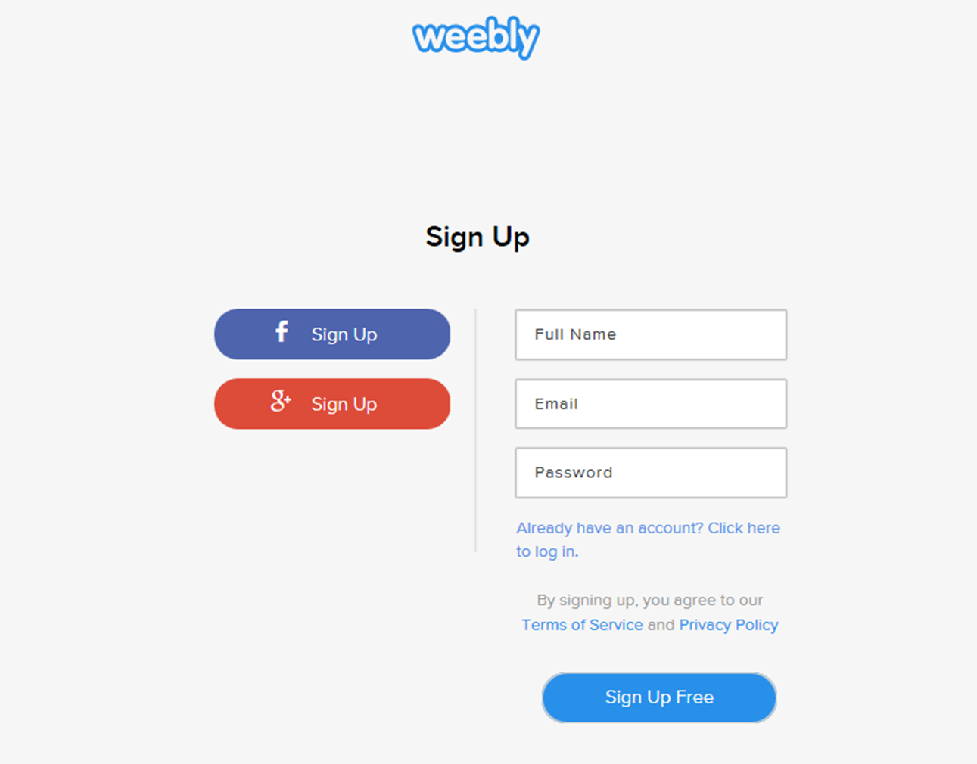

Navigate to www.weebly.com
Click Sign Up in the top right corner

Option 1.
Click red button “g+ Sign Up”
Choose your google account, log in to your google account
Click “Accept”
Click “Create new Weebly account” (in the left column)

Option 2.
Type your name, google email and password
Click “Sign Up Free”

- Create a web site

Step a. Choose a web site format
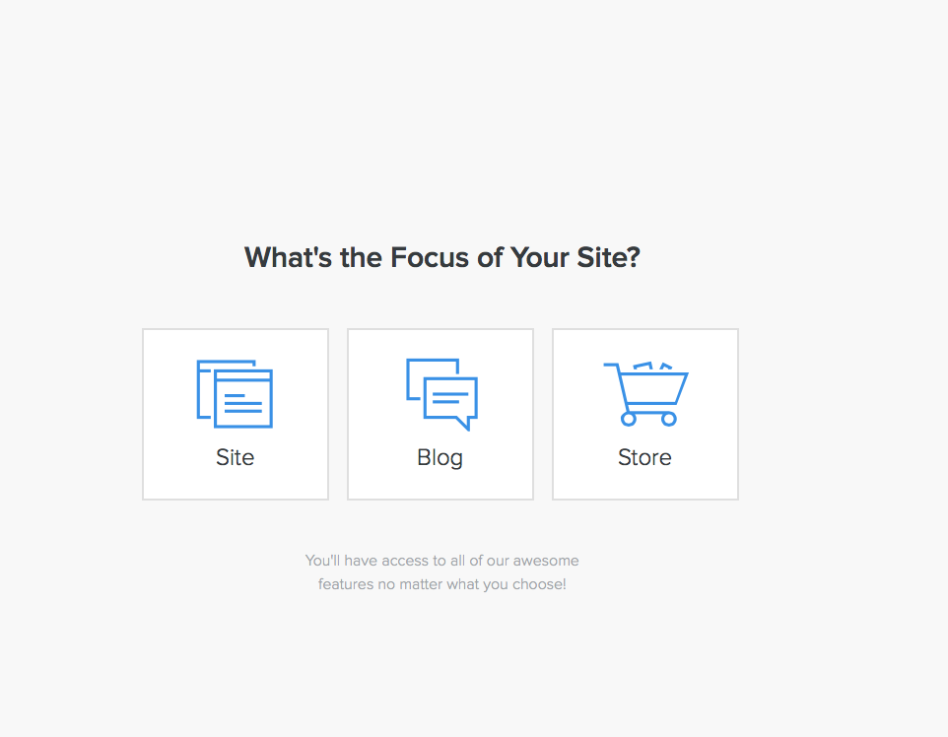
Click “Site”

Step b. Choose a theme
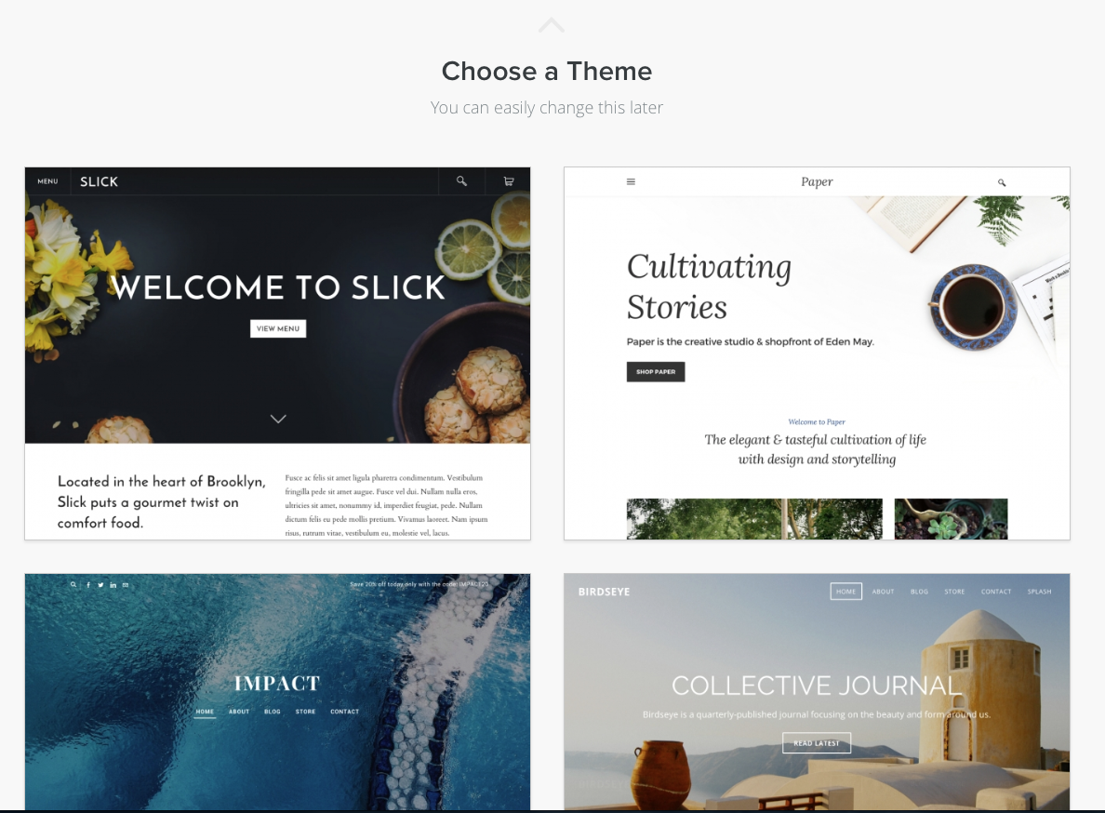
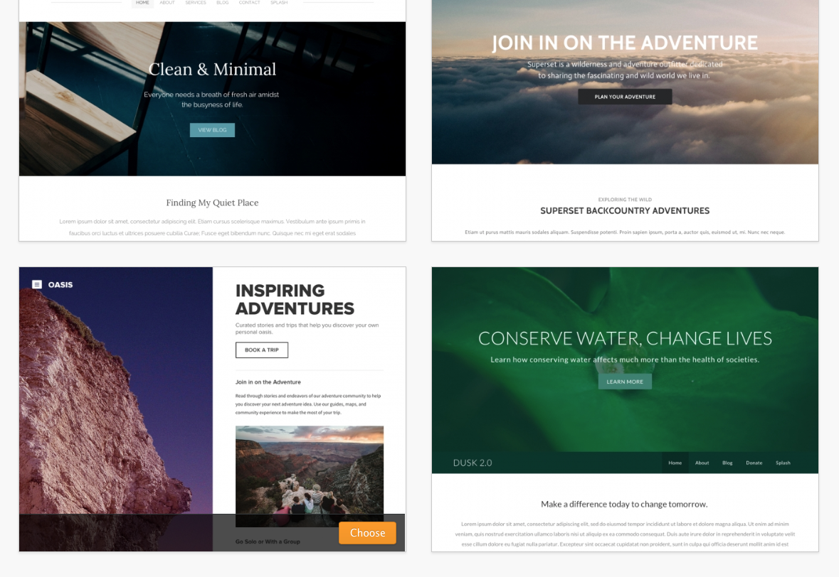
- Choose a theme from the provided templates. For this demo you will be using “Inspiring Adventures”
- Click “Inspiring Adventures”
- “Choose” button will appear on the drop box
- Click “Choose”
- After choosing your theme you will be proposed to choose your domain

Step c. Create a domain
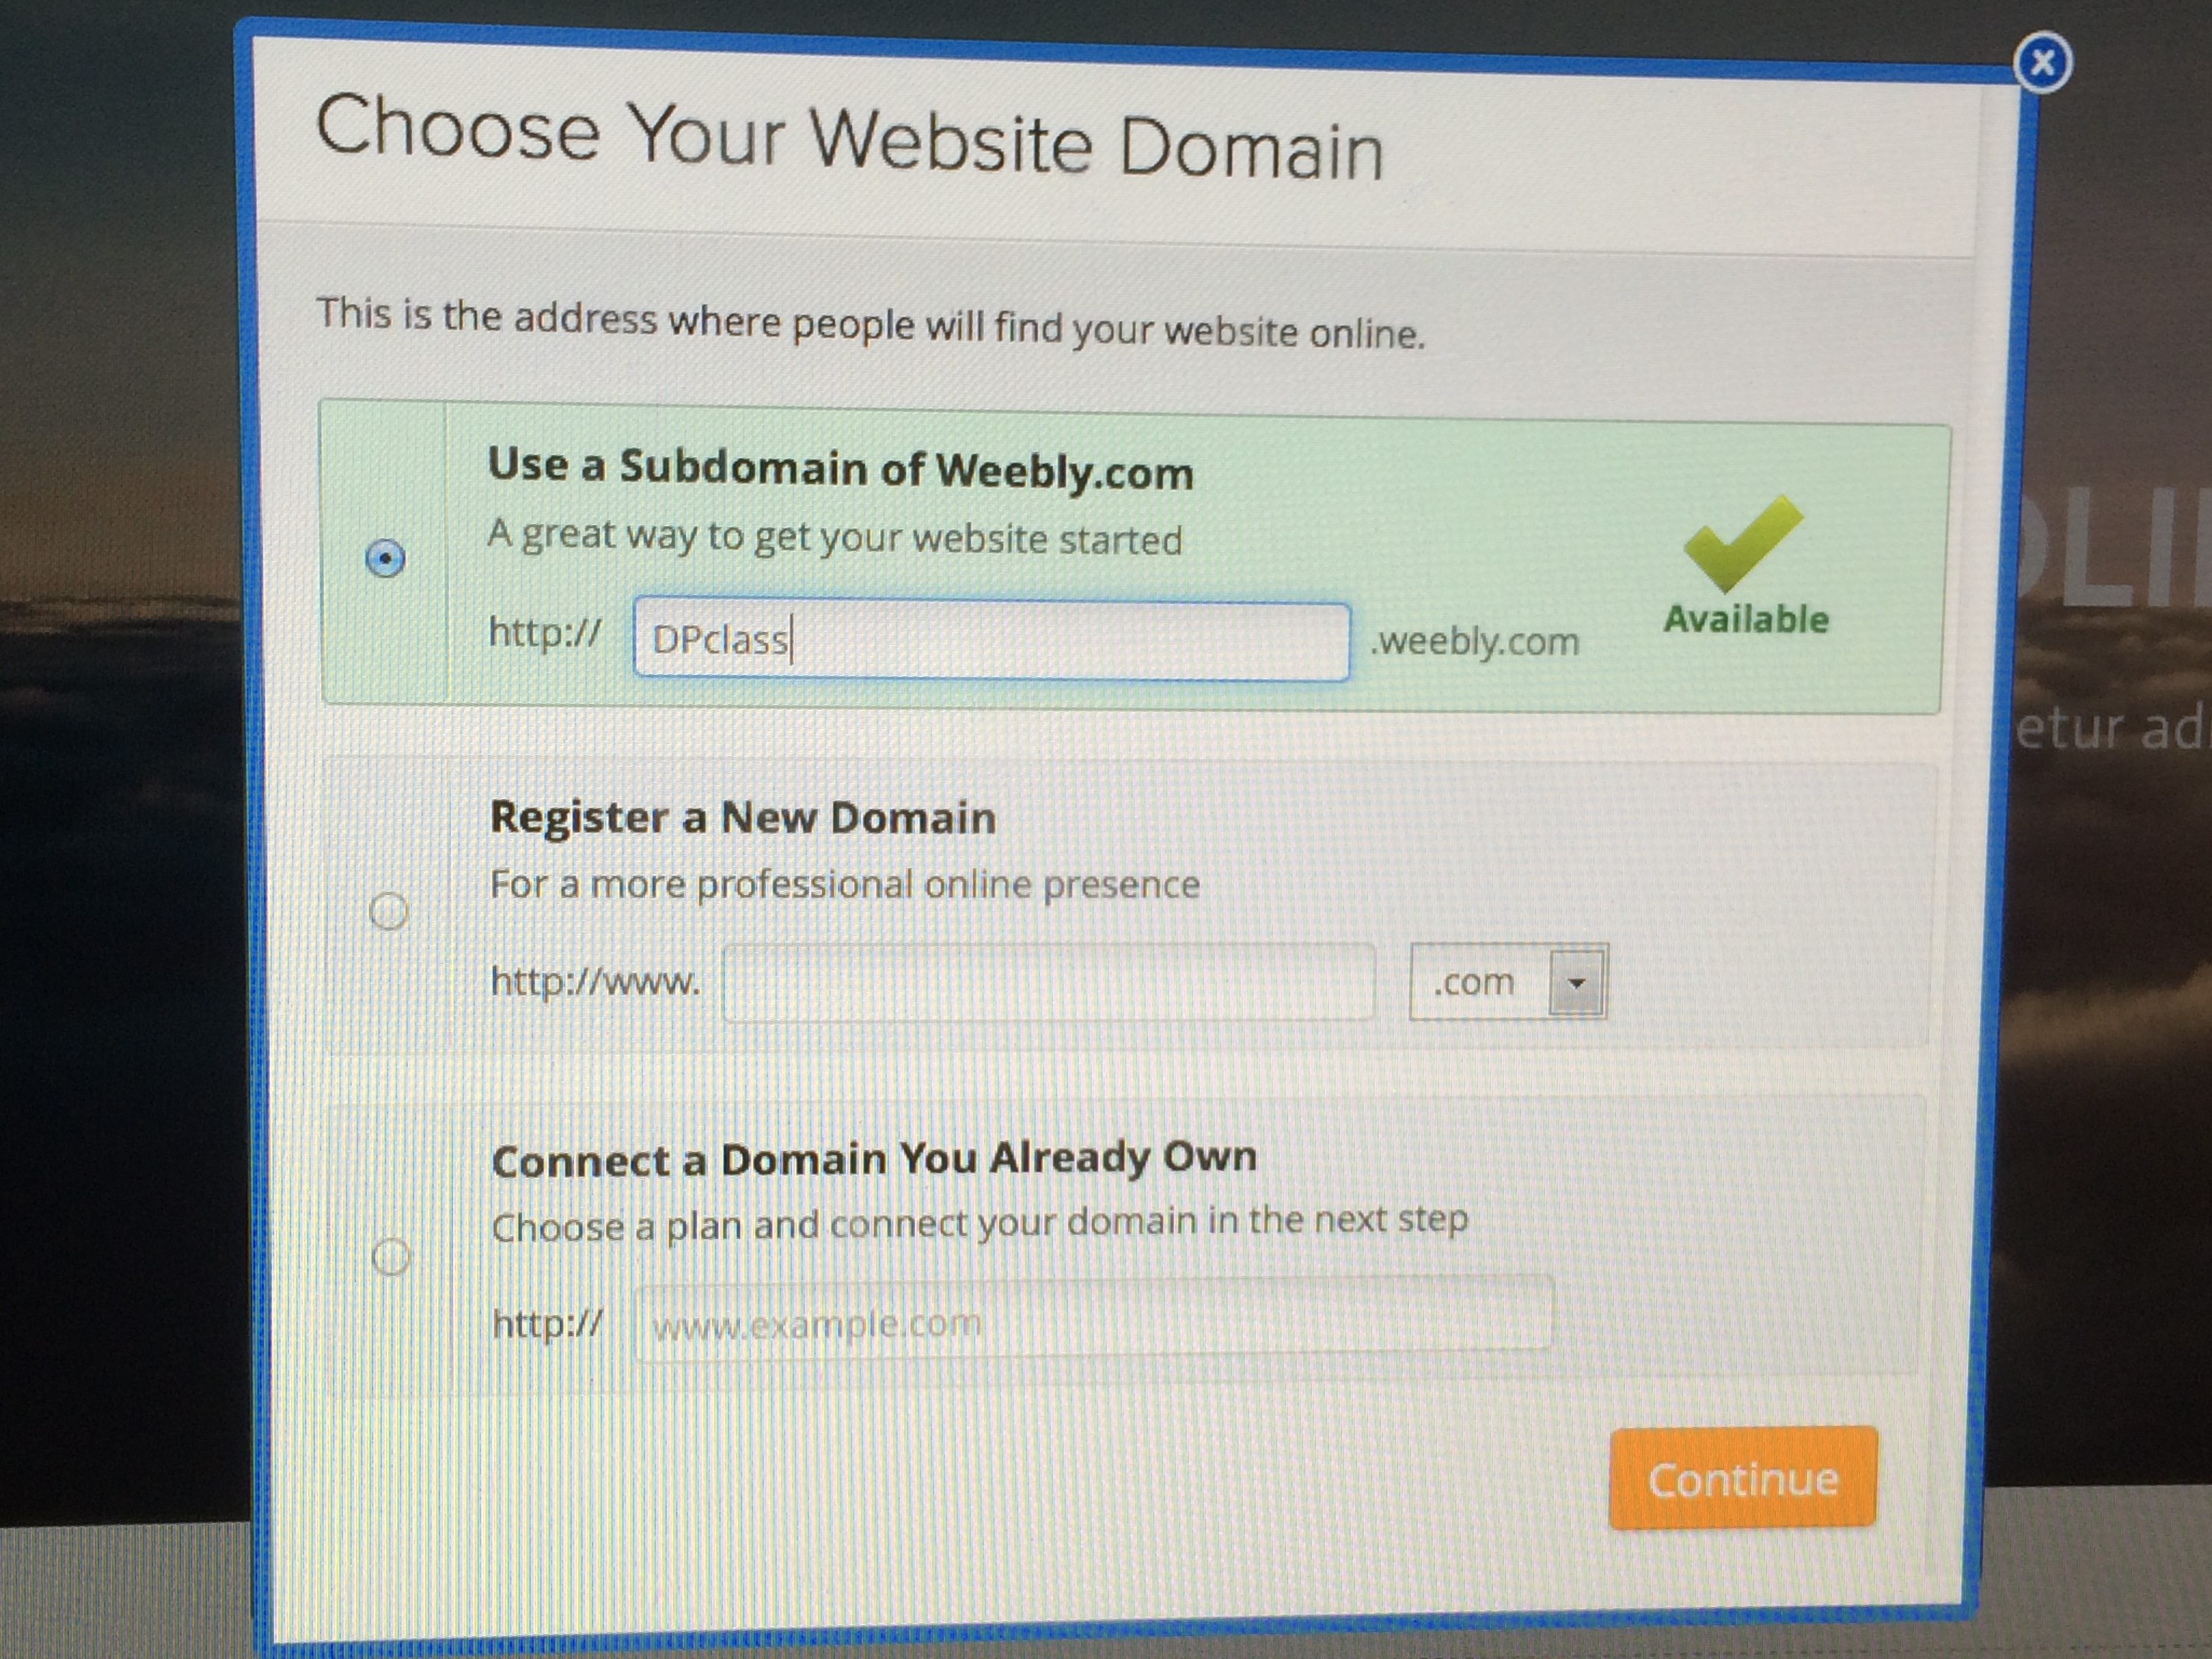
- Choose a subdomain of Weebly.com
- Create a domain name for your web site.
- Type the name in the open box. Domain name should be short, easy to remember and hard to misspelled.
- Make sure that this domain name is available
- Click “Continue”

- Edit your web site
Step a. Create pages
- Your web site should have 5 pages: Home, About, Services, Gallery, Contact
- Some pages of the list already present in your web site. Other pages you need to create.
- To create a page, go to the top left menu called Pages
- Click “+” next to “Pages”
- Click “Standard Page”
- Name your page (type the name in the shown box, instead of “New Page”)
- Click “Save”
- Click on the page, hold and drag it to the place between pages where you want it to be (see the order in #1).

Step b. Choose a layout
- Click “Choose a layout” button. We will be using different layouts for different pages.
- After you choose the layout, click “Keep”. Make sure that you chose the right layout before click “Keep”
- Please see the recommended layout for every page:

- Layout for “Home” page
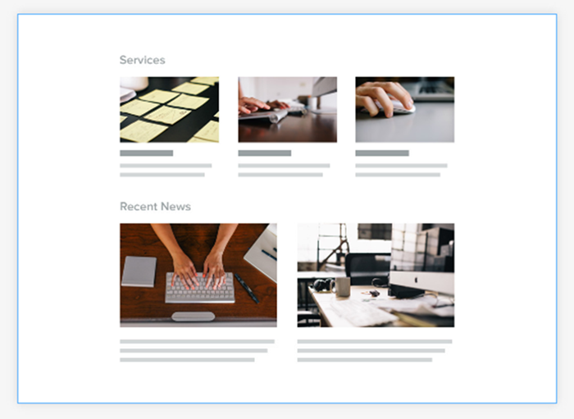
- Layout for “About” page
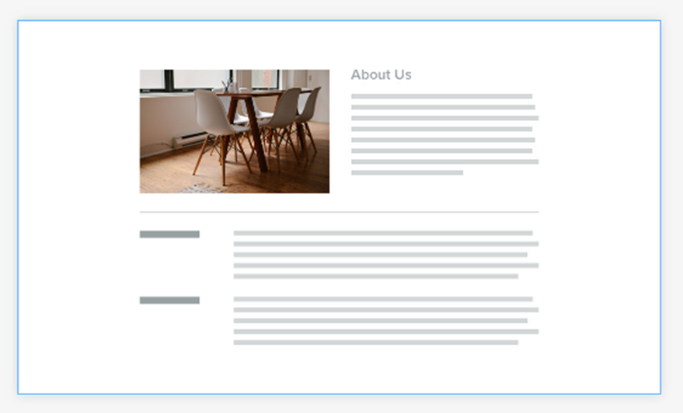

- Layout for “Services” page
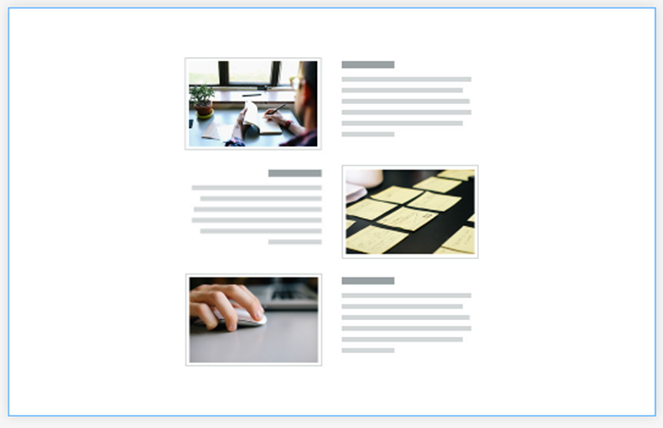

- Layout for “Contact” page
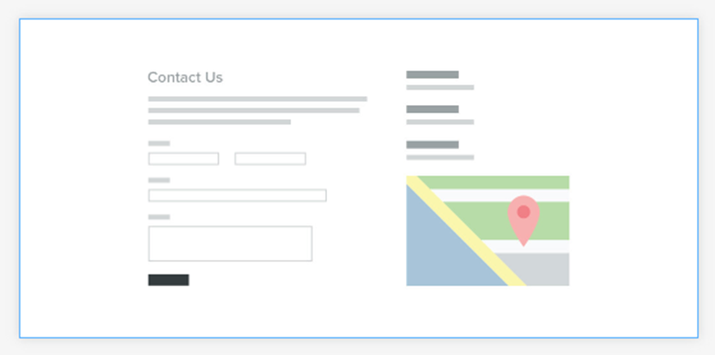
- Layout for “Gallery/ Portfolio” page
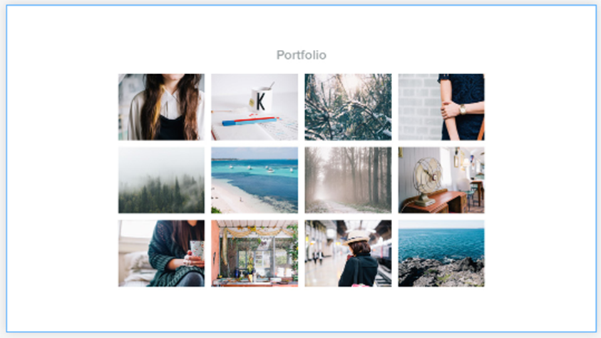

Step c. Change title, headline, text, text button
1. Click “My Site” and change the name to “Travel Agency”
2. Click on “Add headline” and type your headline
3. Click on “Add text” and type your text
4. To change button text, click “Button”. In drop box choose button text. Click and type your text there.

Step d. Change the title image
- Click on the picture that you want to change
- Click “Edit Image”
- Click on the image from the list that you like (don’t upload your own pictures!!!)
- Click “Select”
- Click “Save” (on the top right corner)
- Click “Save to all pages” (please don’t use other options!!!)

Step e. Change other pictures
- Click on the picture that you want to change
- In the drop box click “Replace Image”
- Choose from the provided options:
- My Computer: you can drag photo from your Desktop or Upload from your computer
- Search: you can search for Images: click in the banner menu “Search”> type Alaska> click Search> Free photo> Select Image
- Image URL: you can also find you picture in the Internet and insert its URL. Search for images in Google> in search box type Alaska> Images> Search Tool> Usage rights> Labeled for reuse> Choose your image (image should be in JPEG, GIF or PNG)>copy URL> go to your Weebly site> Image URL> Paste copied URL> Insert

Step f. Change theme, fonts, background
- Choose “Design” in the banner menu
- Find menu in the left top corner
- Choose from the menu options

Step g. Links
For this project we will use links on Home, Services pages, and Contact pages.

On Home page:
- Find “Button”
- Change Button text (using instructions #4 from Step c) to “Print a coupon”
- In drop box menu click “Link” > “File” > “Upload a new file”
- Upload your print advertisement flyer (your first project on print advertisement)

On Services page:
  - Choose “Build” in the banner menu
  - Find menu in the left, scroll down until you see “Button” (under Structure)
  - Click “Button”, hold and drag it to the page
  - Place “Button” under every picture (you should have 3 buttons)
  - Change Button text (using instructions #4 from Step c) to “Learn more”
  - In drop box menu click “Link” > “Website URL” > Copy URL of your upload> Paste the copied URL in the open box>Save
  - Upload to different buttons: 1 file from google drive, 1 video and 1 picture from the Internet (1 thing per 1 button)

On Contact page:
1. Choose “Build” in the banner menu
2. Find menu in the left, scroll down until you see “Button” (under Structure)
3. Click “Button”, hold and drag it to the page
4. Place “Button” under actual email address
5. Change Button text (using instructions #4 from Step c) to “Contact us”
6. In drop box menu click “Link” > “Email” > type your email> Save

Step h. Publish
  - When you finish editing, click “Publish” to make your site visual for other people.
  - Copy your website URL
  - Send an email with your website URL to your teacher

