Basic of HTML and CSS
- Create a new TextEdit document: on your computer go to Finder > Applications> TextEdit
- Select “Format”> “Make Plain Text”
- Select “File” > “Save as” or “Save”
- Save the file as: index.html
- Save your file on Desktop
- You will be asked if you want to use “html” … do that

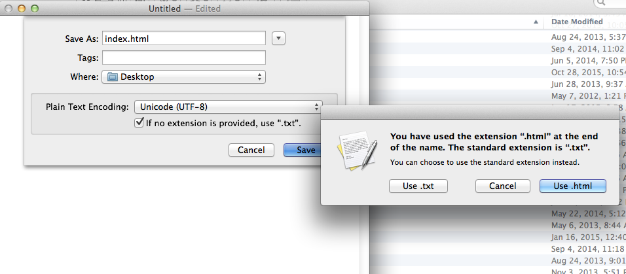

- Type or copy and paste this text in the file index.html

<html>
<head>
<title> My Cool Web Site </title>
</head>
<body>
<p>
This is the body of my homepage
</p>
</body>
</html>

- Open your webpage from internet browser: Right mouse click on index.html file on Desktop > Open with > Google > you should My Cool Web Site in your browser line and text “This is the body of my homepage”
- Create another TextEdit document: “File” > New
Select “Format”> “Make Plain Text”
Select “File” > “Save as” or “Save”
Save the file as: style.css
Save your file on Desktop
You will be asked if you want to use “css” … do that
- Link your index.html file to style.css: in your html file type <link rel="stylesheet" type="text/css" href="style.css"> between </title> and </head>
<html>
<head>
<title> My Cool Web Site </title>
<link rel="stylesheet" type="text/css" href="style.css">
</head>
<body>
<p>
This is the body of my homepage
</p>
</body>
</html>

- Add 5 main elements of a webpage to your index.html file: in your html file replace <p>This is the body of your homepage</p> with this...
<div id="container"></div>
<div id="header"><p> Header Goes Here</p></div>
<div id="sidebar"><p> Left Navigation Goes Here</p></div>
<div id="content"><p> Content Goes Here</p></div>
<div id="footer"></div>

- Your text should look like this:
<html>
<head>
<title> My Cool Web Site </title>
<link rel="stylesheet" type="text/css" href="style.css">
</head>
<body>
<div id="container"> </div>
<div id="header"> Header Goes Here</div>
<div id="sidebar"> Left Navigation Goes Here</div>
<div id="content"> <p>Content Goes Here</p></div>
<div id="footer"> Footer Goes Here </div>
</body>
</html>

- Open your style.css file. Type or copy and paste this text there:
body {background: #ffffff; margin: 0; padding: 0;}
a {color: #2b2bf6;}
#container {width: 900px; margin: 0; padding: 0; background: #dddddd;}
#header {width: 900px; height: 150px; margin: 0; padding: 0; border: 0; background: #f346e1;}
#sidebar {width: 200px; height: 400px; margin: 0; padding: 0; border: 0; float: left; background: #f0e811;}
#content {width: 700px; height: 400px; margin: 0; padding: 0; border: 0; float: left; background: #8be0ef;}
#footer {width: 900px; height: 70px; margin: 0; padding: 0; border: 0; float: left; background: #000000; clear:both;}

- Go to your webpage > Right click > Reload
- Your webpage should look like this:

Explain the role of links.
<a> is main link tag, “href” specifies the destination address.
Students type in their html files:
<p><a href="html_images.asp">HTML Images</a> is a link to a page on this website.</p>
<p><a href="http://www.w3.org/">W3C</a> is a link to a website on the World Wide Web.</p>

<h2>Unordered List with Default Bullets</h2>
Creating a list:
<ul>
<li>Print Advertisement</li>
<li>Tv Commercial</li>
<li>Web Design</li>
</ul>
Change colors: 140 color names: http://www.w3schools.com/html/html_colornames.asp
Resources: http://www.2createawebsite.com/build/build-html-website.html
http://www.w3schools.com
https://www.youtube.com/watch?v=0afZj1G0BIE
http://www.loyola.edu/edudept/facstaff/marcovitz/WWW/WordPad.html

